Buzz

MAKE YOUR TAX DEDUCTIBLE DONATION TODAY

OUR NEED FOR PROJECT FUNDS IS URGENT



**Bringing Up Independent Talented and Insightful Young Adults**

Empower Girls Through Education!

***December 2010***

**Project Funding *Scholarships***

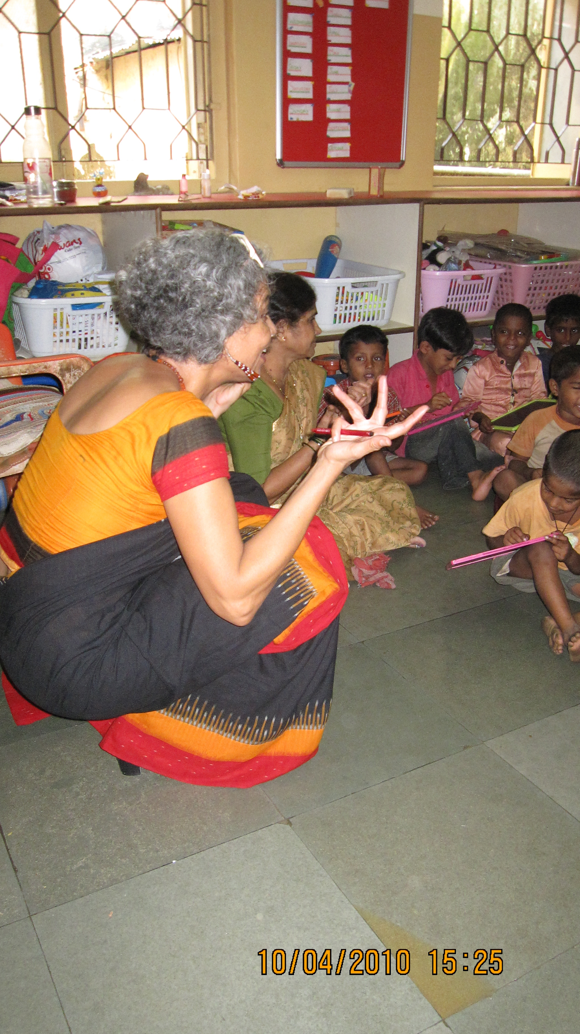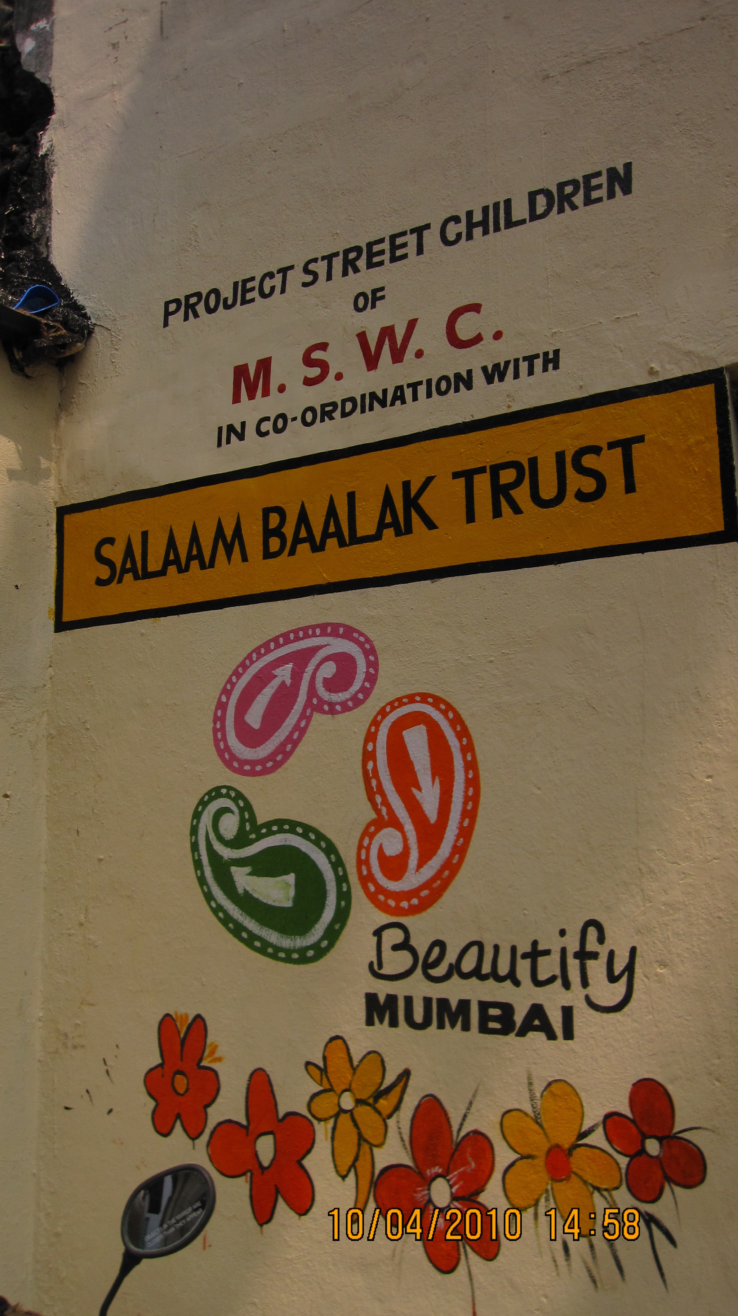

* Salaam Baalak Trust (Mumbai) **$18,000** for demand-driven educational intervention for potentially vulnerable street children. Both formal and informal education devoted to girl children is aimed at inculcating independence, responsibility, and social values by restoring a sense of security through 24-hour shelters.

*“Thank you for the receipt of a total of US $18,000 towards the functional of the Salaam Baalak, Mumbai”,* Dinaz , Founder Salaam Baalak

* Project Prayas (All India) **$1,257** to enable a cross-section of indigent girls across India to pursue their education at the primary, secondary, and college levels, helping them to overcome social stigma and economic deprivation. Mentors help these girls become strong, self-sufficient women.
* Pardada Pardadi Education Society (Anoopshahr, UP) Students learn academic skills along with marketable vocational skills in addition to earning about $666 per pupil by the time of high school graduation. The school deposits $0.30 per student for each day that student attends school.

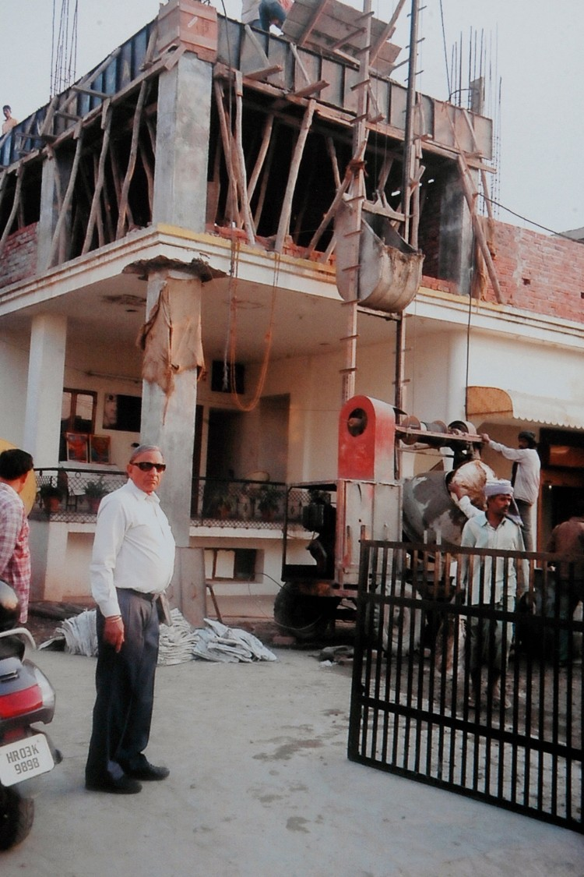

***Vocational Training***

* Bharat Vikas Parishad (Panchkula, Haryana)  **$20,000** to construct and operate Bitiya Vikas Kendra, a State of the art vocational center for girls from slum areas.
* Mijwan welfare Society (Azamgarh, U.P.) Combines girls’ education with vocational training.

***Entrepreneurial Training***

* I Create Inc.(Baroda, Gujarat) **$725** for a non –profit organization conducting courses in entrepreneurship training in a low –income high school

**Feedback from Beneficiaries**

**Activities and Events**



Two major fundraising events were held this year to sold-out audiences:

* **An Evening with Mira Nair** in May (a film screening, silent auction, and dinner with the film director)
* **Broken Images** in October(a play by **Girish Karnad** starring the famed **Shabana Azmi**)

***Bitiya* sincerely thanks all its sponsors for their generosity at both events.**

**Looking Ahead**

As we move forward to the New Year and beyond, we plan to **build a solid fiscal foundation** **for Bitiya** to fulfill its mission of serving underprivileged girls who will become the leaders of tomorrow.

**HELP A GIRL CHILD BY SUPPORTING BITIYA WITH YOUR TAX DEDUCTIBLE DONATION!! !!!TODAY!!!**

*Bitiya* (which in Hindi means "daughters") was started by a group of volunteer women in New Jersey for the purpose of unlocking girls' talents through education and social up liftment. *Bitiya*'s main focus is to fund educational projects for girls in India and elsewhere.

***Bitiya* is registered as 501(c)(3) Tax ID - 26-14106681**

P.O. Box 171, Colts Neck, NJ 07722. Phone: 732-688-7249 or 732-245-2957.Email: [info@bitiya.org](mailto:info@bitiya.org) Web: [www.bitiya.org](http://www.bitiya.org)

Follow us on Facebook

Unsubscribe - info@bitiya.org